**UNIVERSITY OF ENGINEERING AND TECHNOLOGY, LAHORE**

**(NAROWAL CAMPUS)**

**­**

**NAME :**

**ABDULAHAD HUSSAIN**

**ROLL NO. :**

**549**

**SECTION:**

**A**

**SUBJECT:**

**PROGRAMING FUNDAMENTAL**

**LAB #06:**

**Program No. 1:**

In a tabular format, print the integers from 0 to 9, their squares and their cubes.

Num square cubes

0 0 0

1 1 1

2 4 8

**Source code:**

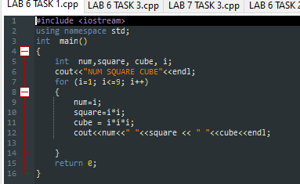

**OUTPUT:**

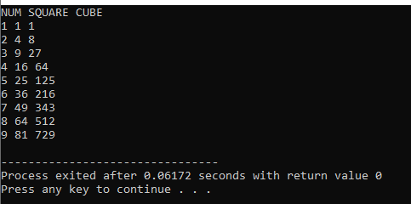

**Flow Chart:**

**END**

Num, Square, Cube

Num = i;

Square=i * i;

Cube = i * i * i;­

Condition

for (i=0; i<=9; i++)

NUM, SQUARE, CUBE

**START**

**FALSE**

**TURE**

**Program No. 2:**

Write a program that take grades secured by the students of a class as input and print description of the grade of a student. If the student has grade ‘A’ we print ‘Excellent’ and 'Very good', 'good', 'poor' and 'fail' for grades B, C, D, and F respectively. Note: use switch statement.

**Source Code:**

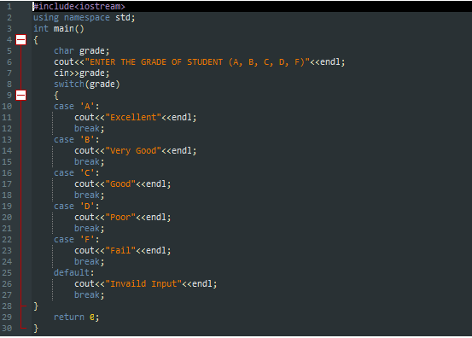

**Output:**

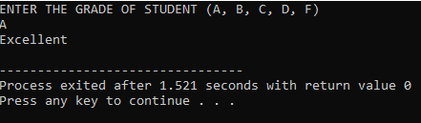

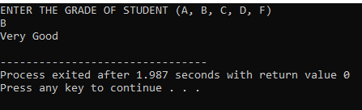

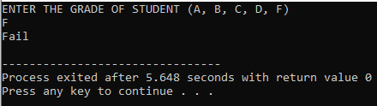

**Flow Chart:**

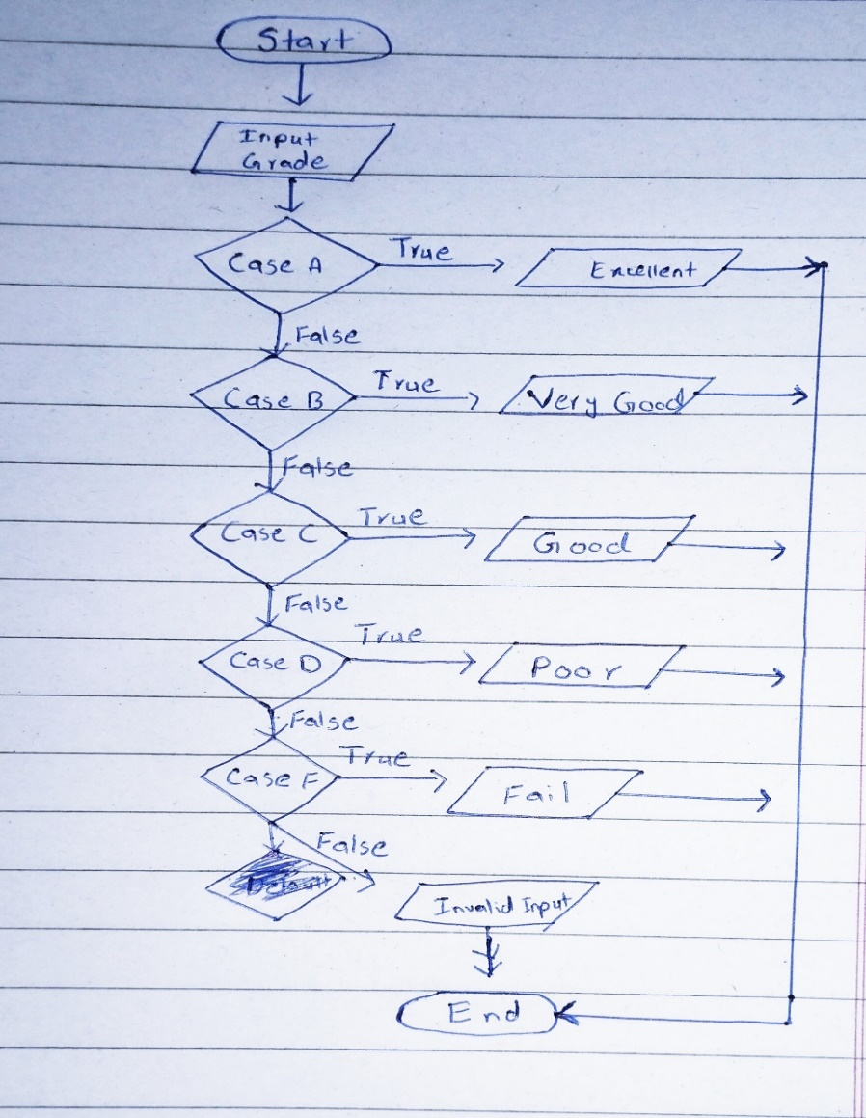

**Program No. 3:**

In a company, there are deductions from the salary of the employees for a fund. The deductions rules are as follows: If salary is less than 10,000 then no deduction If salary is more than 10,000 and less than 20,000 then deduct Rs. 1,000 as fund If salary is equal to or more than 20,000 then deduct 7 % of the salary for fund. Take salary input from user and after appropriate deduction show the net payable amount. Note: use switch statement.

**Source Code:**

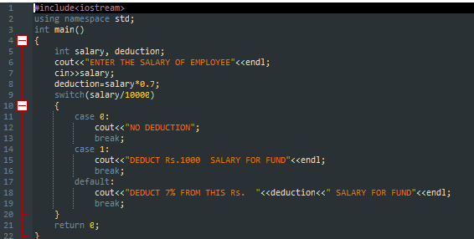

**Output:**

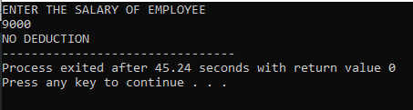

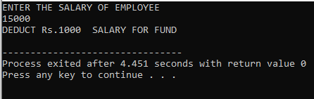

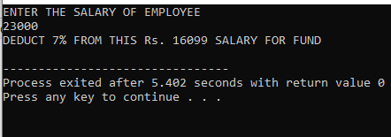

**Flow Chart:**

